
Internship Project Report on
BookEHealth
Submitted in partial fulfilment of the requirement for the award of degree of Master of Computer Application (MCA)
at
University of Mumbai
Submitted by
Gayatri Mahajan
Under the guidance of
Dr. Nidhi Poonia

Bharati Vidyapeeth’s
Institute of Management and Information Technology
Sector 8, CBD Belapur, Navi Mumbai

1. System Study

1.1 Overview of the System
The proposed system is a digital healthcare and learning management platform developed for BookEHealth and LernProfessional. The system provides online healthcare consultation, appointment booking, diet plan management, prescription management, online meeting integration, report management, and healthcare tools.
The system also supports educational and professional learning modules through LernProfessional. The platform is designed to improve communication, management, accessibility, and operational efficiency.
The system consists of:
- Web Application
- Mobile Application
- Healthcare Admin Panel
- Doctor/Dietician Dashboard
- User/Patient Dashboard

1.2 What Is the Organization Looking for With This Solution?
- Automates appointment management and supports online consultations.
- Reduces manual paperwork and improves communication between users and healthcare professionals.
- Provides secure report, prescription, and online payment management.
- Enables digital healthcare services with healthcare tools and tracking systems.
- Offers scalable, secure cloud-based services and supports learning and professional development modules.

1.3 Current System Overview
Currently, most healthcare and learning organizations use manual or semi-digital systems for managing appointments, consultations, reports, and patient records.
Existing System Characteristics:
- Manual appointment booking process
- Limited online consultation support
- Reports shared through WhatsApp or email
- No centralized healthcare tracking system
- Separate systems for prescriptions and diet plans
- Poor report organization and management
- Lack of proper online meeting management
- Limited chat and communication functionality
- Time-consuming patient record management

1.4 Flow of Data
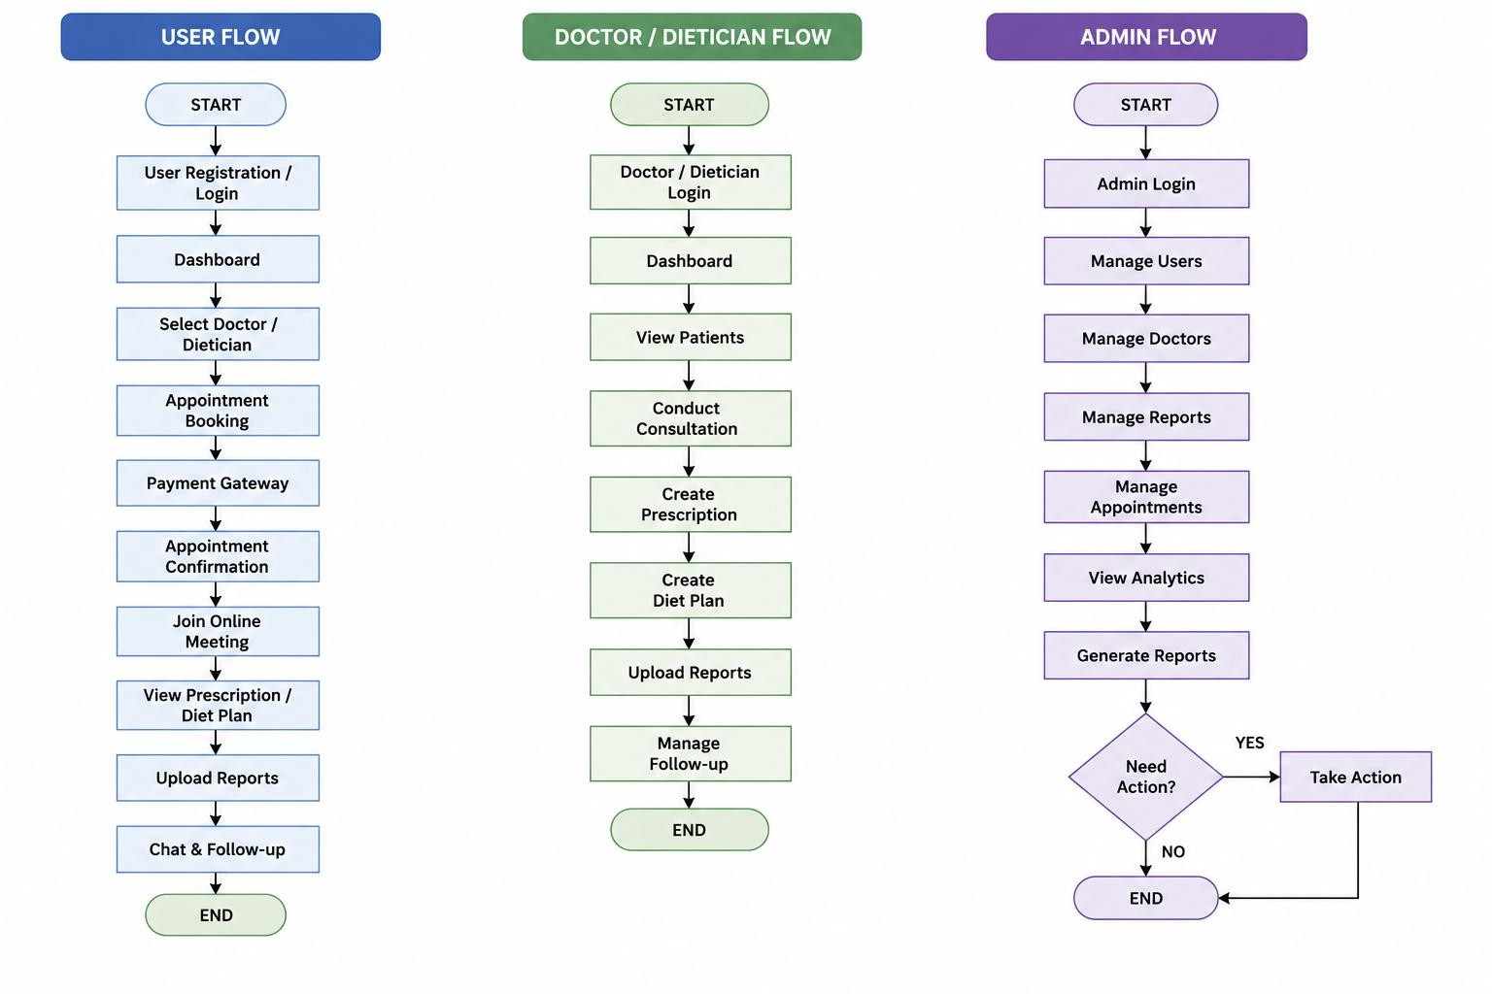

1.5 Proposed System
- The proposed system is a centralized healthcare and learning management platform that automates appointments, online consultations, prescriptions, diet plans, report management, and communication between users and healthcare professionals.
- The system is designed for both web and mobile applications to provide secure, fast, and user-friendly digital healthcare services.

1.5.1. Proposed Flow
- User registers/logs in → selects doctor/dietician → books appointment → completes payment → joins online consultation → receives prescription/diet plan → uploads reports → communicates through chat and follow-up services.
- The system ensures smooth healthcare workflow, secure data handling, and easy access to healthcare services.

1.5.2. Overall Functionality
- The system follows a three-level hierarchy: Admin, Doctor/Dietician, and Patient/User, where each user has specific roles and permissions.
- Admin manages users, doctors, appointments, reports, and analytics; doctors manage consultations, prescriptions, and diet plans; users can book appointments, attend meetings, upload reports, and access healthcare tools.

1.5.3. Overall Features of the Current System
- The current system supports appointment booking, online consultation, report upload/download, prescription management, diet plan management, payment integration, and healthcare tools.
- It also includes Zoom meeting integration, user dashboards, doctor dashboards, and chat functionality for healthcare communication.

1.5.4. Limitations of the Current System
- Reports and uploads take too much time to load, meeting minimization and PiP mode are not functioning properly, and some chat features are unstable.
- Diet plans, prescriptions, report sorting, and appointment management features are not properly optimized, affecting overall user experience.

1.5.5. How the Proposed System Overcomes the Limitations
- The proposed system improves report loading speed, meeting management, appointment sorting, and healthcare communication efficiency.
- It provides better Zoom integration, centralized healthcare tracking, enhanced UI/UX, secure data management, and improved prescription and diet plan visibility.

1.5.6. Similar Software / Existing Systems
Existing healthcare systems include:
- Practo
- Apollo 24/7
- Tata 1mg 4. mfine
- DocsApp
- HealthPlix
Features provided by existing systems:
- Appointment booking
- Online consultations
- Digital prescriptions
- Patient records
- Healthcare communication
The proposed system improves:
- Diet plan handling
- Zoom integration
- Report management
- User experience
- Healthcare workflow
- Appointment tracking
- Online healthcare tools

1.5.7. History of the Project Domain
- Healthcare systems evolved from manual hospital processes to digital healthcare platforms supporting telemedicine, online consultations, and electronic health records.
- Modern healthcare applications focus on cloud-based systems, real-time communication, secure data management, and centralized patient healthcare tracking.

1.5.8. Research Papers, Surveys, and Case Studies
- Research papers and surveys on telemedicine and healthcare management systems highlight the importance of online consultation, digital healthcare services, and centralized patient management.
- Case studies show that digital healthcare platforms improve operational efficiency, reduce patient waiting time, and enhance healthcare accessibility and communication.

2.1 Define the Problem
The healthcare industry still faces difficulties in managing appointments, consultations, reports, prescriptions, and patient communication efficiently.
Existing systems are partially manual, time-consuming, and lack centralized healthcare management, which affects user experience and operational efficiency. This project is required to provide a secure, centralized, and user-friendly digital healthcare management platform for web and mobile applications.

2.2 Mapping Out the Problem
The healthcare management problem can be divided into the following components:
Appointment Management
Online Consultation Management
Prescription Management
Diet Plan Management
Report Upload & Download
Payment Integration
Chat and Communication
Meeting Management
2.3 Describe the Problem
Actors and Entities

1. Patient/User
- Patients can register/login, book appointments, join online meetings, upload reports, and view prescriptions and diet plans.
- The system helps users manage healthcare services digitally in a secure and centralized platform.

2. Doctor/Dietician
- Doctors and dieticians can conduct consultations, create prescriptions and diet plans, upload reports, and manage patient records.
- They can also communicate with users through chat and provide healthcare guidance online. 3. Admin
- Admin manages users, doctors, appointments, reports, and overall healthcare operations.
- Admin can monitor system activities, analytics, and maintain platform performance.

Business Rules
- Only registered users are allowed to book appointments and access healthcare services.
- Payment confirmation is mandatory before online consultation begins.
- Doctors and dieticians can create prescriptions and diet plans, while users can securely upload reports.
- Meetings should maintain proper state during minimization without disconnecting the session.

2.4 Problem Statement Must Include

i. Decisions and System Adjustments
- The system should improve report loading speed, upload performance, and appointment management.
- Zoom meeting integration, minimization handling, and meeting restoration should work properly.
- Prescription visibility, diet plan management, and chat communication features should be enhanced.

ii. Performance Measurements
- Report loading time should be reduced to less than 5 seconds for better user experience.
- Appointment booking should provide instant confirmation and real-time updates.
- Meeting restoration and chat functionality should work smoothly without interruptions.

iii. Constraints
- The system depends on stable internet connectivity and server performance.
- Browser compatibility, Zoom API integration, and payment gateway limitations may affect functionality.
- Device compatibility and third-party service dependencies are important constraints.

3. Requirement Gathering

3.1 Business Process Understanding
- The healthcare workflow includes registration, appointment booking, consultation, payment, report handling, and follow-up management.
- Interactions between users, doctors, dieticians, and admin modules should be properly analyzed and managed.

3.2 Process Steps
- User Registration/Login → Doctor Selection → Appointment Booking → Online Payment → Consultation → Prescription/Diet Plan Generation → Report Management → Chat & Follow-up.
- The process ensures smooth healthcare service management from booking to consultation completion.

3.3 Inputs, Outcomes, and Business Rules

Inputs
- User details, appointment information, payment data, reports, and prescriptions are used as system inputs.
- Accurate and secure data entry is important for proper healthcare management.

Outcomes
- Successful appointment booking, online consultation, report management, and prescription generation are expected outcomes.
- The system should provide secure and efficient healthcare services to users.

Business Rules
- Valid login and payment confirmation are mandatory before consultation.
- Users can access only their own healthcare records and reports securely.
- Reports and healthcare data must be stored and managed securely.

3.4 Types of Requirements

1. Business Requirements
- Improve healthcare service efficiency and reduce manual work.
- Enhance communication between users and healthcare professionals.
- Provide reliable and scalable digital healthcare services.

2. Functional Requirements • Login, registration, appointment booking, payment integration, and online consultation should function properly.
• The system should support chat, prescription management, diet plans, and report upload/download features.

3. Technical Requirements
- The system should support secure database management and cloud-based hosting.
- Zoom SDK
- Razorpay integration
- Responsive UI/UX
- cross-platform support

3.5 Deliverables
- Requirement Gathering Document, Test Cases, Test Scenarios, and Bug Reports are key project deliverables.
- Checklists, Exit Criteria, and Final Project Documentation should also be prepared.

3.6 Estimation & Planning (Gantt Chart)
- Requirement Gathering and System Design are planned for 1 week each.
- Development is planned for 3 weeks, followed by Testing for 2 weeks.
- Bug Fixing and Deployment are planned for 1 week each.

4. Methodology

4.1 Testing Techniques Employed
- Functional Testing, Regression Testing, Smoke Testing, Integration Testing, and UI Testing are used.
- Performance Testing, Load Testing, and Automation Testing are also performed for system validation.

4.2 Testing Process
1. Test Planning
• Testing scope, objectives, and strategy are defined during the planning phase.
2. Test Design
• Test cases and test scenarios are prepared based on requirements.
3. Test Execution
• Manual and automation test cases are executed and validated.
4. Defect Reporting and Management
• Defects are logged, prioritized, assigned, and retested after fixes.

5. Test Closure
- Test summary reports are prepared and exit criteria are verified before closure.

4.3 Tools and Technologies
Testing Tools
- Selenium, JIRA, Postman, and BrowserStack are used for testing activities.

Technologies Used
- Java, Selenium WebDriver, TestNG, Angular, Firebase, Razorpay, and Zoom SDK are used in the project.

4.4 Test Environment Setup
Hardware
- Windows 11 laptop with Intel Processor and 8GB RAM is used for testing.

Software
• Eclipse IDE, Chrome Browser, Selenium WebDriver, and Java JDK are used for development and testing.

Challenges Faced
• ChromeDriver compatibility, dynamic Angular elements, Zoom integration, and slow report loading were major challenges.

4.5 Test Data

Test Data Used
• User details, appointment data, payment information, reports, and prescription data are used for testing.

Test Data Management
• Test data is created manually and maintained securely for testing purposes.

4.6 Test Case Design
Techniques Used
- Boundary Value Analysis
- Equivalence Partitioning
- Decision Table Testing
- Error Guessing
- State Transition Testing

Example Test Cases
TC ID | Scenario | Expected Result
TC_01 | Valid Login | User should login successfully
TC_02 | Appointment Booking | Appointment should book successfully
TC_03 | Upload Report | Report should upload successfully
TC_04 | Join Meeting | User should join meeting successfully

